- Mobile app screenshots
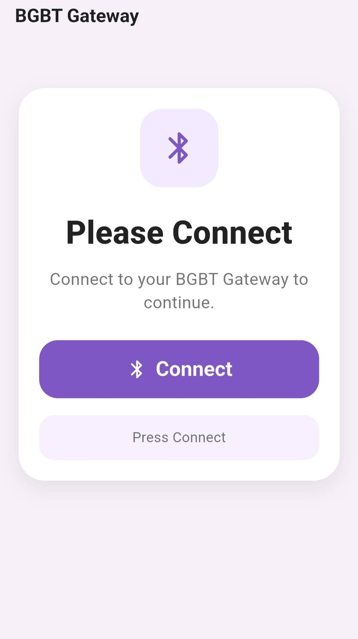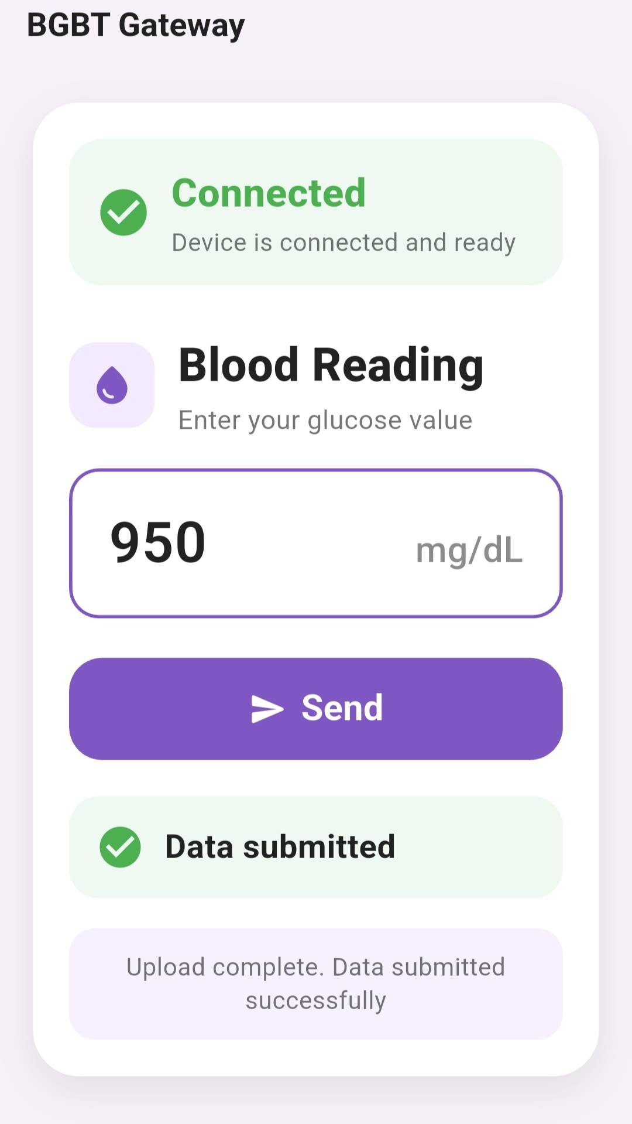
- Database architecture explanation
I used Supabase, which is a relational SQL database
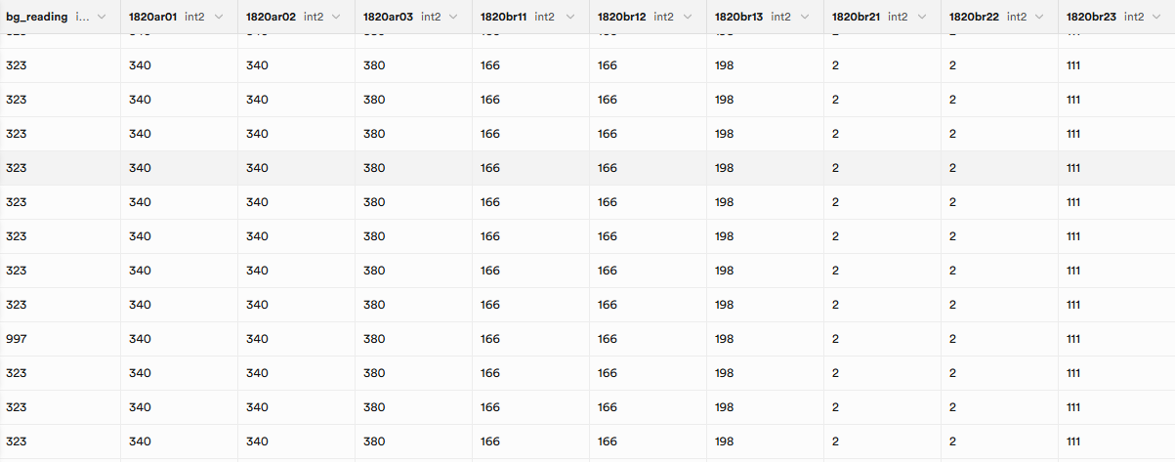
- BLE workflow explanation
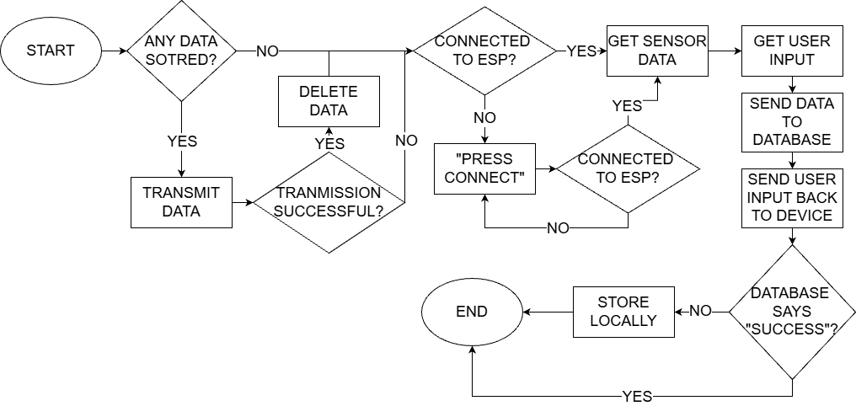
- Cloud upload workflow
It uses an endpoint on Supabase to map the information from a key value pair to the correct columns on the database

Database Architecture Explanation
The project uses Supabase as the cloud database platform. Supabase provides a hosted relational SQL database, so the system stores sensor readings in a structured table rather than as unorganized text files or raw Bluetooth messages. In this project, the main database table is named sensor_readings.
The database is designed around one main idea: each completed measurement cycle from the BLE gateway becomes one row in the database. A row contains the device identifier, the platform identifier, the user-entered blood glucose reading, and the sensor values received from the ESP32 gateway.
The main fields inserted into the database are:
Database Field | Purpose
device_id | Identifies which BLE gateway/device sent the data. This comes from the d query parameter.
pltfrm_id | Identifies the platform or reading type. This comes from the p query parameter.
bg_reading | Stores the blood glucose value entered by the user in the mobile app.
2600ar01 to 2600br23 | Stores sensor group values mapped from BLE keys a1 through a9.
2602ar01 to 2602br23 | Stores sensor group values mapped from BLE keys b1 through b9.
2603ar01 to 2603br23 | Stores sensor group values mapped from BLE keys c1 through c9.
2620ar01 to 2620br23 | Stores sensor group values mapped from BLE keys e1 through e9.
1820ar01 to 1820br23 | Stores sensor group values mapped from BLE keys f1 through f9.
The mobile application does not insert data directly into the database. Instead, it sends the data to a Supabase Edge Function. The Edge Function acts as a secure middle layer between the app and the database. This is important because the database service role key is stored only on the server side inside the Edge Function environment variables, not inside the Flutter app.
The database architecture therefore follows this structure:
Mobile App → Supabase Edge Function → Supabase Database Table
This structure improves security and organization. The app only needs to know the public Edge Function endpoint, while the Edge Function handles validation, formatting, and insertion into the sensor_readings table. The screenshot in the uploaded report shows this database table storing blood glucose readings and multiple sensor columns.

BLE Workflow Explanation
The mobile app communicates with the ESP32 gateway using Bluetooth Low Energy, or BLE. The app is built with Flutter and uses the flutter_blue_plus library to scan, connect, receive sensor data, and send user input back to the ESP32.
The BLE workflow begins when the user presses the Connect button. The app first requests the required Bluetooth and location permissions. After permissions are granted, the app scans for a BLE device that matches either the expected device name, BGBT_FEATHER_V2, or the expected BLE service UUID:
6E400021-B5A3-F393-E0A9-E50E24DCCA9E
Once the target device is found, the app stops scanning and connects to the device. After connecting, the app discovers the device services and looks for two BLE characteristics:
Characteristic | UUID | Purpose
RX Characteristic | 6E400022-B5A3-F393-E0A9-E50E24DCCA9E | Used by the phone to write data to the ESP32.
TX Characteristic | 6E400023-B5A3-F393-E0A9-E50E24DCCA9E | Used by the ESP32 to notify/send data to the phone.
After the TX notify characteristic is found, the app enables notifications. This allows the ESP32 to send data to the phone automatically. The app then sends the message:
READY
This tells the ESP32 gateway that the phone is connected and ready to receive a payload.
The ESP32 sends sensor data to the phone as a text-based payload. The app expects the BLE payload to use a query-string style format, such as:
d=1&p=BG&a1=...&b1=...&c1=...&e1=...&f1=...
The app receives BLE data in chunks, so it uses a buffer to collect incoming text until it finds a newline character. Once a full line is received, the app parses the payload by splitting the text into key-value pairs. The app checks that the required fields exist before accepting the payload. A valid payload must include:
d, p, a1, b1, c1, e1, and f1
After a valid payload is received, the app stores it in lastParams. At this point, the system has the sensor data from the ESP32, but it still needs the user’s blood glucose reading.
The user enters the blood glucose value in the app screen. When the user presses Send, the app sends the blood glucose value back to the ESP32 using the RX characteristic. It sends two messages:
BG=<value>
CONFIRM bg=<value>
This confirms the user-entered reading to the ESP32 device. The app then combines the BLE sensor payload with the blood glucose reading and prepares the full dataset for cloud upload. The uploaded report’s BLE diagram matches this process: connect to the ESP, get sensor data, get user input, send data to the database, and store locally if the database upload fails.

Cloud Upload Workflow Explanation
The cloud upload workflow begins after the app has both parts of the data:
- Sensor data received from the ESP32 over BLE
- Blood glucose value entered by the user in the Flutter app
The app combines these values into one set of upload parameters. The blood glucose value is added as the bg parameter. The app also ensures that the platform parameter p exists, defaulting it to BG if needed.
The Flutter app sends the data to the Supabase Edge Function using an HTTP GET request. The upload endpoint is:
/functions/v1/sr
The app sends the data as URL query parameters. For example, the request includes values such as:
d, p, bg, a1, a2, b1, c1, e1, f1, and so on.
On the server side, the Supabase Edge Function receives the request and reads the query parameters. It first checks that the Supabase environment variables are available:
Environment Variable | Purpose
SUPABASE_URL | The Supabase project URL.
SUPABASE_SERVICE_ROLE_KEY | A secure key that allows the function to insert into the database.
The Edge Function then validates the required values. It checks that:
- d is a valid device ID.
- p is a valid platform ID.
- bg is a valid blood glucose reading.
- Numeric sensor values are valid integers within the small integer range.
After validation, the Edge Function creates a row object for the database. It maps the short BLE parameter names into the correct database columns. For example:
BLE Parameter Group | Database Column Group
a1 to a9 | 2600ar01 to 2600br23
b1 to b9 | 2602ar01 to 2602br23
c1 to c9 | 2603ar01 to 2603br23
e1 to e9 | 2620ar01 to 2620br23
f1 to f9 | 1820ar01 to 1820br23
Once the row is built, the function inserts it into the Supabase table:
sensor_readings
If the insert is successful, the Edge Function returns:
Data submitted successfully
with HTTP status code 200.
If the upload fails, the mobile app does not immediately lose the data. Instead, it stores the failed upload locally on the phone using SharedPreferences. The app keeps a local upload queue with a maximum of 10 pending uploads. Each queued upload also receives a deduplication key generated using a 32-bit FNV-1a hash. This prevents the same reading from being stored multiple times in the local queue.
The app automatically retries failed uploads. It starts retrying after 5 seconds and increases the retry delay up to 60 seconds if uploads continue to fail. When the cloud upload eventually succeeds, that item is removed from the local queue.
Overall, the cloud workflow is:
Flutter App receives BLE payload → User enters blood glucose → App sends GET request to Edge Function → Edge Function validates and maps data → Edge Function inserts row into Supabase → App stores locally and retries if upload fails
This design makes the system more reliable because data can still be preserved temporarily on the phone even when the internet connection or cloud service is unavailable.
Give me all of this in a

References
[1] Supabase, “Supabase Documentation: Database,” Supabase Docs. Accessed: May 21, 2026. [Online]. Available: Supabase documentation.
[2] Supabase, “Edge Functions,” Supabase Docs. Accessed: May 21, 2026. [Online]. Available: Supabase Edge Functions documentation.
[3] Supabase, “Environment Variables and Secrets,” Supabase Docs. Accessed: May 21, 2026. [Online]. Available: Supabase Functions secrets documentation.
[4] Supabase, “supabase-js JavaScript Client Library,” Supabase Docs. Accessed: May 21, 2026. [Online]. Available: Supabase JavaScript client documentation.
[5] Deno, “Deno.serve,” Deno Documentation. Accessed: May 21, 2026. [Online]. Available: Deno API documentation.
[6] C. Weinberger, “flutter_blue_plus,” Pub.dev. Accessed: May 21, 2026. [Online]. Available: flutter_blue_plus package documentation.
[7] Android Developers, “Bluetooth Low Energy Overview,” Android Developers. Accessed: May 21, 2026. [Online]. Available: Android BLE documentation.
[8] Bluetooth SIG, “Bluetooth Low Energy,” Bluetooth Technology Website. Accessed: May 21, 2026. [Online]. Available: Bluetooth SIG documentation.
[9] Flutter, “Flutter Documentation,” Flutter. Accessed: May 21, 2026. [Online]. Available: Flutter framework documentation.
[10] Dart Team, “Dart Documentation,” Dart. Accessed: May 21, 2026. [Online]. Available: Dart language documentation.
[11] Flutter Community, “permission_handler,” Pub.dev. Accessed: May 21, 2026. [Online]. Available: permission_handler package documentation.
[12] Flutter Community, “shared_preferences,” Pub.dev. Accessed: May 21, 2026. [Online]. Available: shared_preferences package documentation.
[13] Dart Team, “http package,” Pub.dev. Accessed: May 21, 2026. [Online]. Available: Dart HTTP package documentation.
[14] Project Team, “BGBT Gateway Mobile Application Source Code,” unpublished senior design project source code, 2026.
[15] Project Team, “Supabase Edge Function for Sensor Reading Upload,” unpublished senior design project source code, 2026.
[16] Project Team, “BGBT Gateway Senior Design Report Draft Screenshots and Workflow Diagram,” unpublished project document, 2026.

